Hit the “members” tab and then “My Profile”
Enter your account information and hit “login” Button
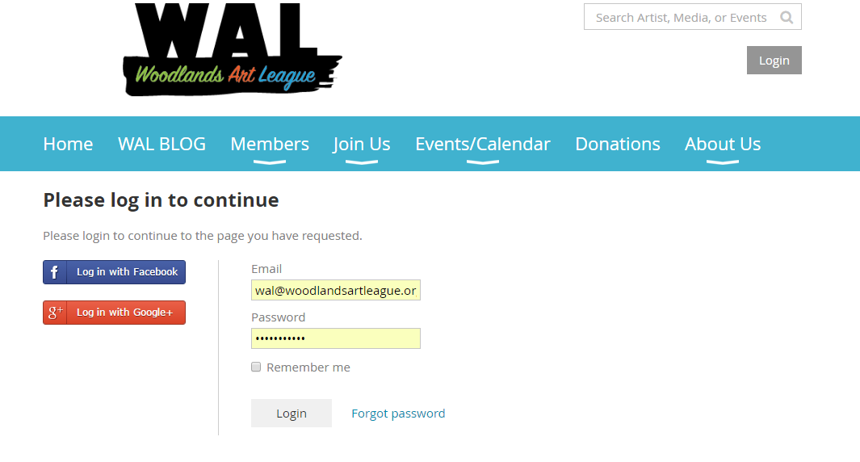

Hit the “member photo Albums” button
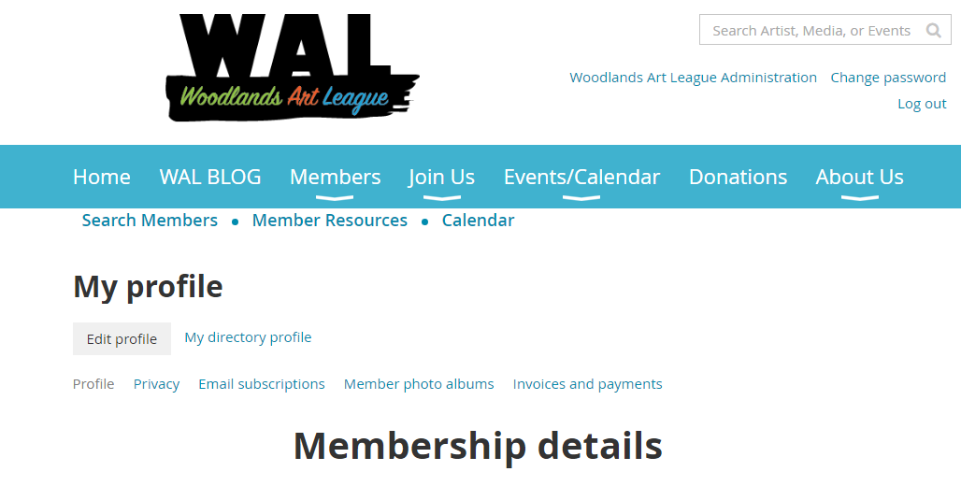
Hit the album “Whatever you named it” (ignore “you have reached your album limit you only get one but you can load 50 photos into it)
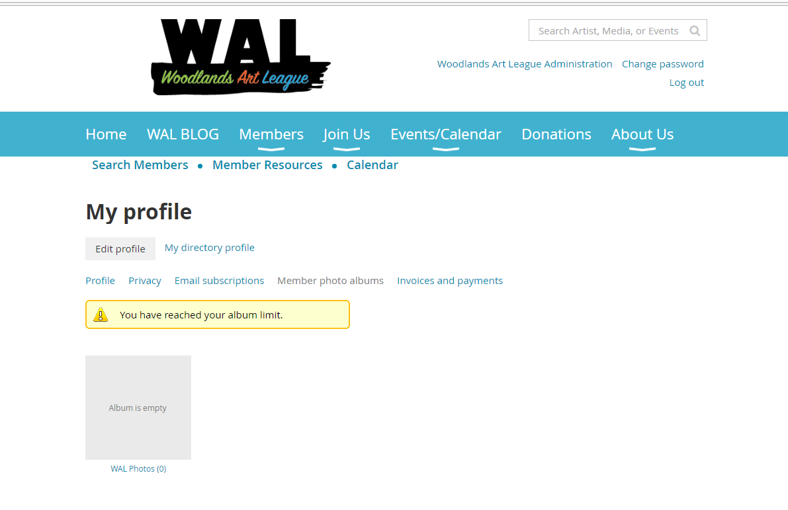

Hit the “upload button”
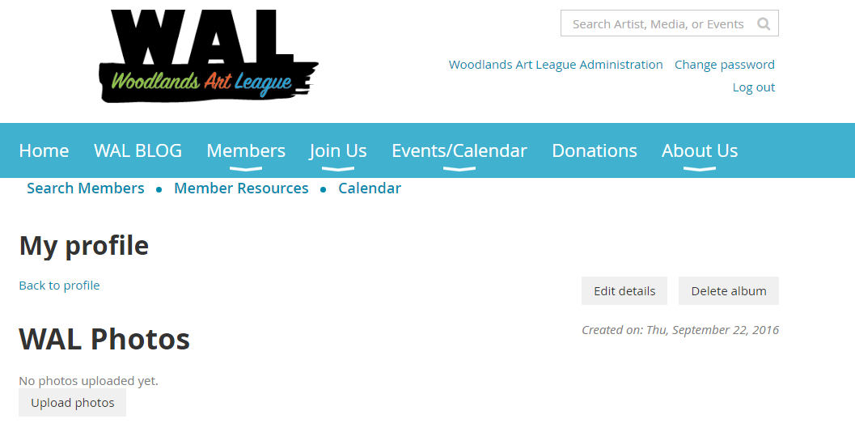

No start uploading up to 50 photos. Make sure they are in the correct support formats as stated below.
